**- PRESS RELEASE –**

***Young Europeans debate ideas for the future/A SOLIDARY FUTURE at the european parlIament***

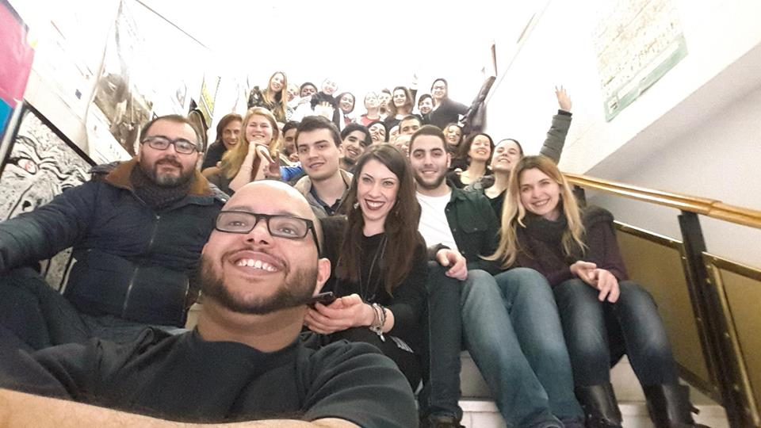

**Utrecht, November 24, 2016 |** Young adults from 18 European countries will **debate** and share ideas on a “Solidary Europe for ALL” at the **European Parliament** and with staff of **the European Commission on November 29th**. They close the day with a **debate in Vaartkapoen**, **with youth from Molenbeek about** **‘How to change your neighborhood’.**

Promoted by **IDEA (International Debate Education Association)** as part of **“OPEN UP! Connecting youth to society”** program, this initiative brings the voices of young adults from different communities across Europe to an enthusiastic debate where they will have the opportunity to present their views and solutions for the current challenges facing Europe. After an intense debate in their territories these groups of talented young adults are reinforcing the importance of developing key soft skills and promoting critical thinking when considering the future of new generations.

Comprehending a wide variety of motions as:  **“Guarantee access to scholarships for young immigrants”, ‘Prevent radicalisation by empowering youth to organise small scale debates with authorities at neighbourhood level’, ‘support critical thinking and debating skills across Europe and allow critical debates and participation of young people at all levels in the society’, ‘Recognise non formal skills as important competences for young people’**

‘Start empowering young people at an early level!’

This inspiring debate contradicts the idea of apathy relating political subjects that is sometimes attributed to young people’. In a period of deep uncertainty in Europe where extremist groups and exclusion of minorities grows this young adults propose solutions to tackle the challenges facing Europe today and do so in participative grounds, involving different actors in their communities and building collective responses for a humanized and solidary Europe.

IDEA NL is the International Debate Education Association based in the Netherlands . IDEA aims to contribute to democracy, tolerance and peace building through debate education for young people. IDEA NL is an association of 17 members who are debate network organisations and has a broad network of partners who work with youth with fewer opportunities. IDEA NL is part of the IDEA Network.

**OPEN UP!** Is an initiative by youth- debate- human rights organisations, debate coaches, artists and young people. OPEN UP! Partners work together to connect young people with fewer opportunities to society through logical, creative, and action oriented debate education methodologies. OPEN UP! Is active in more than 9 European Countries. OPEN UP! See [www.openupconnect.org](http://www.openupconnect.org) Open UP! Partners are:

